NEWSLETTER | AUGUST 2014
Disability Federation of Ireland
An advocate for the voluntary disability sector
Supporting organisations to enable people with disabilities

Government Must Use Budget 2015 to Ensure that Nobody is Left Behind
Over the past number of years, it has become ever clearer just how badly the outcomes of previous Budgets have left people with disabilities behind. The Disability Federation of Ireland (DFI) is using its Pre-Budget Submission to make the case for an inclusive society that leaves nobody behind.
Budget 2015 must break the chain of previous austerity budgets and address the growing levels of hardship in which these people unjustly find themselves. The growing confidence in economic recovery must also translate into confidence in knowing that people have a strong fabric of health and social supports behind them: the downturn can no longer be used as a reason for depriving disabled people their ability to participate in life.
This budget must adopt a three-fold approach of delivering adequate income supports, inclusive labour markets and quality services, restoring a strong health and social services infrastructure which protects people with disabilities and their families. Supplementary income supports must be acknowledged as part of a person’s basic income and safeguarded as such, while access to robust services and mainstream activation programmes which support disabled people to live with independence and well-being is also essential.
Those involved in Government have to regularly confront decisions on the spending of public money, and, in that, they must understand that what they determine reveals exactly where their priorities, values and motivations lie. Clearly, and in the face of commitments previously made, they don’t lie with disability. Government now faces an opportunity to demonstrate its ambition and responsibilities to people with disabilities in changing that.
We are not just fighting for people with disabilities and their families; we are fighting for this country to have a heart and soul. Ireland’s future rests on whether we’re going to be an open, inclusive and participatory society. The decisions taken in the upcoming Budget must not lead us to question whether that future includes people with disabilities.
John Dolan, Chief Executive Officer

DFI Welcomes Restoration of SSNO Funding to 23 Disability Organisations
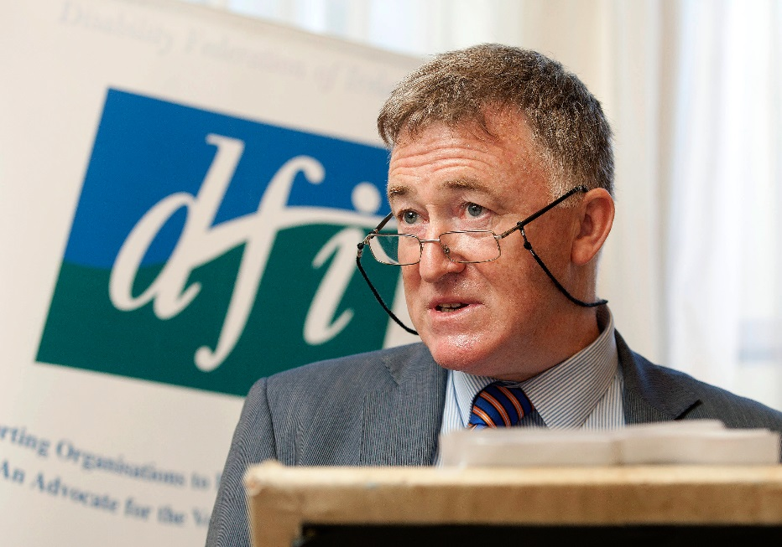

Chief Executive of DFI, John Dolan, speaking at the press briefing on SSNO funding on 9th July

The Disability Federation of Ireland (DFI) welcomed the announcement on 18th July from the Minister for the Environment, Alan Kelly, that 23 disability organisations are to see their funding continued under the Scheme to Support National Organisations for a twelve-month period.
On 30th June, 26 disability and caring-oriented organisations saw their funding through the Scheme to Support National Organisations (SSNO), run by the Department of the Environment, Community and Local Government, revoked at a total annual loss of €1.2 million.
Under this development, 23 of these organisations will see the support reinstated, along with several organisations from the wider community and voluntary sector. This funding has been made available as a bridging provision for a twelve-month period, with the amount granted to each organisations based on their allocation so far this year.
Image by Salvatore Vuono, courtesy of freedigitalphotos.net

Chief Executive of DFI, John Dolan, stated, “We have fought hard to see this funding restored since the announcement of the 2014-2016 SSNO allocations, and our response is one of sheer relief. This secures the delivery of vital community-based supports and services for another year”.
DFI campaigned for several weeks to highlight the huge concern at the impact this withdrawal of funding would bear on these organisations and the thousands of people they support, and to see the support restored. As an immediate result of the initial decision, several organisations, including the Irish Deaf Society, Huntington’s Disease Association and Muscular Dystrophy Ireland, were forced to reduce or even close some of their services and supports, while many more were likely to do the same in the near future. Others, such as Chronic Pain Ireland and the Neurological Alliance of Ireland (NAI), faced ceasing operations entirely over the next few months.
Mr Dolan explained, “The whole incident highlights the need that the Government’s own implementation mechanisms for the NDS are comprehensively implemented. The situation clearly demonstrates the need for a Minister of Disability Inclusion to be instated, bringing disability issues to the Cabinet table and safeguarding core services in the sector”.
Highlights of the DFI campaign on SSNO funding are recapped below.
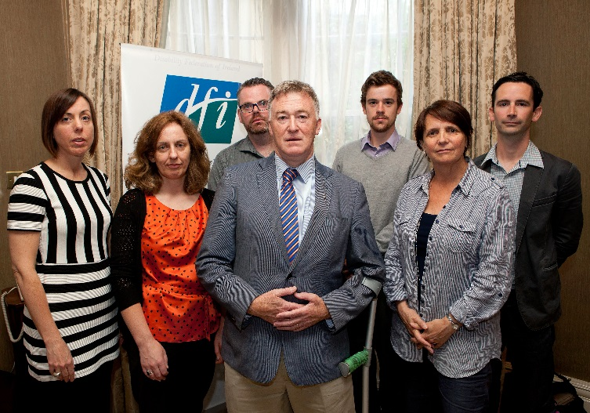
Press Event
On 9th July, DFI held a press briefing to raise awareness of the withdrawal of SSNO funding to the 26 disability organisations during the previous week. Representatives of the affected groups and members of the media attended the event, at which DFI called for the restoration of the funding and the appointment of a Senior Minister for Disability Inclusion during the selection of the new Cabinet later that week.
Stephanie Casey (Arthritis Ireland), Patricia Towey (Huntington’s Disease Association), Séamus McGrath and Phelim Tierney (Brí), Anne Lawlor (GRDO) and Donald Ewing (Dyslexia Association of Ireland) with DFI’s John Dolan at the SSNO press event
To read the statement delivered by John Dolan at this event, please visit http://disability-federation.ie/index.php?uniqueID=10901
Open Letter to Government
On 11th July, DFI wrote to the Taoiseach, Enda Kenny, and the newly-appointed Tánaiste, Joan Burton, seeking the restoration of this funding and the installation of a Senior Minister for Disability Inclusion. This call was repeated in further letters to the Minister for the Environment, Alan Kelly, the Minister of State for Disability, Kathleen Lynch, and to every member of the Oireachtas.
Later, on 16th July, DFI joined with five other umbrella networks whose member organisations were hit by the cuts – NAI, Genetic and Rare Disorders Organisation (GRDO), the Medical Research Charities Group (MRCG), Care Alliance Ireland and the Carmichael Centre for Voluntary Groups – to request a meeting with Minister Kelly on this issue.
During this time, DFI also released an open letter on its website which it encouraged the public to send on to the two Ministers and to their local Oireachtas representatives. This letter was also distributed among organisations who saw their funding revoked, asking their own members to send it on to Government.
To view this letter, go to http://disability-federation.ie/index.php?uniqueID=10902

Press releases
DFI issued three press releases as the SSNO funding issue progressed: to read more, please follow the links below:
- DFI welcomes the restoration of SSNO funding to disability organisations | 18th July: http://disability-federation.ie/index.php?uniqueID=10907
- DFI calls on government to restore SSNO funding to disability organisations | 16th July: http://disability-federation.ie/index.php?uniqueID=10903
- DFI highlights huge concern at withdrawal of Government funding to disability sector | 9th July: http://disability-federation.ie/index.php?uniqueID=10900

DFI Presents Budget 2015 Submission to Department of Social Protection
The Disability Federation of Ireland (DFI) presented its Recommendations for Budget 2015 to the Department of Social Protection (DSP) at a special Pre-Budget Forum for community and voluntary organisations on 4th July.
DFI contended that the upcoming budget must adopt a three-fold approach of delivering adequate income supports, inclusive labour markets and access to quality services to begin the restoration of a strong health and social services infrastructure which protects people with disabilities and their families.
Budget 2015 must value social as well as economic recovery. Image by m_bartosch, courtesy of freedigitalphotos.net

Income protection
Protection of basic income is the first step in this process, but it is crucial that this is not confused with the protection of basic payments only. Everyone should expect and receive an adequate income that supports them to live with dignity, in accordance with their human rights. People with disabilities face a growing need to pay for extra medical, transport and living costs, which, if not suitably accommodated, poses a serious threat to this right.
Supplementary income supports, such as the Household Benefits Package, Domiciliary Care Allowance and the Free Travel Scheme, must therefore be acknowledged as part of a person’s basic income, and protected and bolstered as such. This, along with a €20 increase to the Disability Allowance, would go some way to making that threat less of a reality for the many families it currently looms over.
Access to labour markets and services
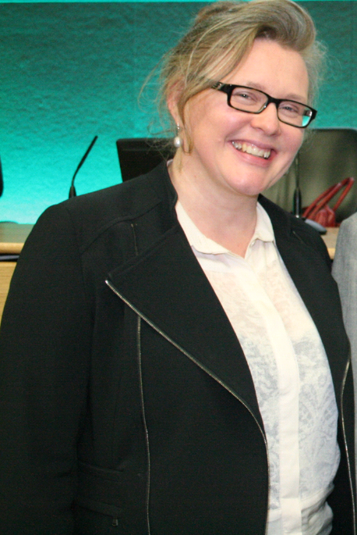
DFI also demanded the provision of supports to mainstream activation programmes which many disabled people find themselves excluded from: the labour market, however troubled it is, must lie open to everyone. There is no justification, for example, in denying people with disabilities access to Intreo offices and schemes such as Pathways to Work, Jobsbridge, Momentum and the Youth Guarantee. Other measures - such as tax credits and a payment similar to Partial Capacity Benefit would support people with disabilities in pursuing self-employment and raising themselves out of poverty.
Finally, Government must act to ensure that it provides access to quality services which are robust enough to support disabled people to live with independence and well-being. This will involve structural reforms, departmental co-ordination, and proper data collection on the status of people with disabilities to inform policy rulings. The recent and welcome decision to suspend the medical card review and have departments work together to grant cards based on need, rather than income, proves how badly this is needed. In this light, DFI is calling for the introduction of disability-adjusted poverty and inequality estimates and equivalence scales to bring about more realistic payments and stronger service provisions for people with disabilities.
DFI Support Officer, Joan O’Donnell, presented the Pre-Budget Submission to Minister Burton
Social recovery
Speaking at the event, DFI Support Officer, Joan O’Donnell, explained, “it is becoming ever clearer just how badly the outcomes of previous budgets have left people with disabilities behind. Cuts to income supports, such as the Mobility Allowance, Housing Adaptation Grant and the infamous medical card review, and barriers to activation measures have pushed this group into a devastating cycle of poverty and deprivation”.
She added, “The growing confidence in economic recovery must also translate into confidence in knowing that people have a strong fabric of health and social supports behind them: the downturn can no longer be used as a reason for depriving disabled people their basic rights as citizens. DFI is making the case for an inclusive society that doesn’t allow this to happen any longer”.
To see DFI’s Submission to the DSP, please visit http://disability-federation.ie/index.php?uniqueID=10894

DFI Nominates Candidates to the Education and Training Boards

The Disability Federation of Ireland (DFI) is awaiting the selection of representatives to the new Education and Training Boards (ETBs), having submitted its nominations in July.
ETBs were established in July 2013, and provide training and education programmes in communities across the country. Their development offers DFI an opportunity to ensure participation in the meaningful implementation of the National Disability Strategy (NDS) at local level.
DFI invited all member organisations to nominate representatives for it to consider for submission to the new ETBs. The organisation was successful in being specified by the Minister both as a body with a special interest in education and training and as a representative of learners, specifically those with disabilities. DFI had sought this recognition in accordance with the Education and Training Boards Act 2013, Section 30 (11), relating to the composition of these boards.
DFI has a strong capacity to participate effectively on the ETBs, with a national network of highly qualified and experienced staff working across the country to strengthen people with disabilities’ access to mainstream public services. Access to and meaningful engagement in further education and training is a critical factor in ensuring the full participation of disabled people in Irish society.
There is the expectation that DFI-appointed candidates will understand their role in the overall context of the broad disability agenda, and that they will engage with DFI and their fellow DFI-nominated representatives on an ongoing basis. The organisation’s staff will actively support people in their roles.
DFI will set up a Network of Interest around this issue from within our membership to ensure the ongoing input of information, data, inclusion and integration to representatives. Those with influence in this area are asked to support DFI’s candidates in this endeavour.
If you have any particular queries on the ETBs or the nomination process, please contact Toni Gleeson, DFI Support Officer, on 086 600 4526. For more information about the ETBs, please visit http://www.etbi.ie/

North West Alcohol Forum Welcomed as New Members to DFI
The Disability Federation of Ireland (DFI) welcomed the North West Alchohol Forum into its membership in July 2014.
The North West Alcohol Forum works to raise awareness of alcohol harm across the island of Ireland, recognizing that this can bear significant social, physical, mental and economic effects. It offers a wide range of resources to the community to highlight alcohol-related harm while, at the same time, advancing solutions to change alcohol culture.
The group promotes community action on alcohol, by delivering education and training to communities on alcohol harm and taking a preventative approach towards them. Its Strengthening Families programme has been shown to have a positive impact on family relationships, reducing involvement in crime, increasing good behaviour and school performance. The group also conducts research on alcohol harm, such as alcohol-related brain injury.
DFI looks forward to working with the North West Alcohol Forum on these issues and to its growing involvement and collaboration with the disability movement over the coming years.
For more information on the North West Alcohol Forum, please visit www.alcoholforum.org. To learn more about the Strengthening Families programme, go to www.sfpnw.com.

DFI Seeks Feedback on its Work from Member Organisations in Online Survey

Here at the Disability Federation of Ireland (DFI), we are currently undertaking a review of our work, and are seeking feedback from our member organisations on a number of different issues, ranging from our communications strategy to our research work.
To this end, we have developed an online survey consisting of 16 short questions, which we are asking all member organisations to complete. This should take approximately five minutes to go through. Member organisations have been contacted individually with a link to the survey, which can be filled in online.
We are hoping to receive the majority of responses by Friday, 16th August.

DFI Hosting New Course on Quality Management for Voluntary Organisations
Applications are now open on an accredited course on quality management, hosted by the University of Limerick (UL) and the Disability Federation of Ireland (DFI) in Autumn 2014.
‘An Introduction to Quality Management for Community and Voluntary Organisations’ comprises five days’ tuition staggered across ten weeks, and will be held in the DFI Head Office.
Quality and accountability
Aimed at managers, development workers, service users and board members of Community and Voluntary (C&V) organisations, the course is designed to develop awareness of the level and type of quality management activities currently in practice. It was successfully run in Autumn 2011, Spring 2012, Autumn 2012 and Spring 2013.
Participants will explore and apply a number of principles, tools and methodologies intended to identify and eliminate ‘waste’ and to achieve efficiencies in their organisations. The course was developed in response to the increasing need for accountability, growing demand for evidence of quality in both services and management, and the recent Value for Money (VfM) Report.
Applications
The programme, divided into five units, takes place between 10.30am and 4.30pm across the following five Saturdays: 27th September, 11th October, 1st November, 15th November, and 29th November 2014. The cost for the course is €600; however, a grant of €100 is being made available to all DFI member organisations.
Image by basketman, courtesy of freedigitalphotos.net

Applications close at 5pm on Friday, 22nd August 2014. If you are interested in this course, please contact Padraic Cooke in the University of Limerick on padraic.cooke@ul.ie.
For more information, contact Eleanor Uí Fhiannachta in DFI by email at eleanoruifhiannachta@disability-federation.ie or by phone on 01 454 7978. Alternatively, contact DFI Support Officer, Dermot O’Donnell, on 086 780 8639 or by emailing dermotodonnell@disability-federation.ie
Further details of the course content are available on the DFI website at http://www.disability-federation.ie/index.php?uniqueID=10905. A description of each week’s programme can also be accessed at http://www.disability-federation.ie/index.php?uniqueID=10904. For feedback from previous participants, visit the UL website at ULearning Elements of Excellence.

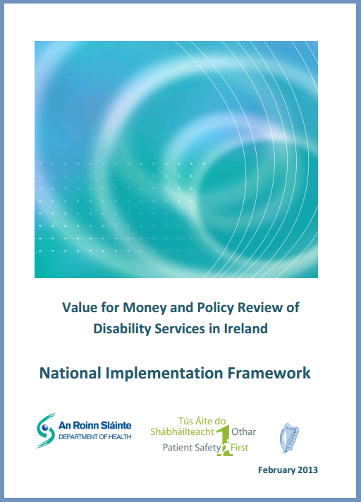
Working Groups Established for Implementation of Value for Money
The Health Service Executive (HSE) has established six working groups under the National Implementation Framework of the Value for Money (VfM) and Policy Review of Services report.
The framework, which outlines seven strategic aims, provides for the development of the six groups and associated sub-groups to support the implementation of the Reform Programme. Membership of the groups has been confirmed, and some have held their first meetings: the Disability Federation of Ireland (DFI) has representatives on all six. Deirdre Scully of the HSE has been appointed Project Lead for this work.
Image by artur84, courtesy of freedigitalphotos.net

The groups established are as follows:
    - Person-Centred Model of Services and Supports: Strategic Planning
Objective: This working group will work on deve loping a strategic plan to drive migration to a person-centred model of services.
DFI Representative: Joanne McCarthy (Senior Executive Officer, Policy and Research).

    - Person-Centred Model of Services and Supports: Implementation, Oversight and Support
Objective: This working group will provide oversight and support in implementing initiatives to drive migration to the person-centred model in 2014. A number of sub-groups will focus on specific projects relating to Congregated Settings, the Review of Adult Day Service, Development of Services 0-18 and Autism Services.
DFI Representatives: PJ Cleere (Support Officer); Alison Ryan (Support Officer); Toni Gleeson (Support Officer).

    - People with Disabilities and Community Involvement
Objective: This working group will work to ensure the involvement of service users in the drive towards person-centred service models.
DFI Representatives: Martin Naughton (Support Officer); Alice Griffin (DESSA).

    - Quality and Standards
Objective: This working group will work on the quality and standards recommendations arising from the VfM report.
DFI Representatives: Dermot O’Donnell (Support Officer); Barbara O’Connell (Acquired Brain Injury Ireland).

    - Management and Information Systems
Objective: This working group will develop an information infrastructure to support the effective delivery of the Disability Services Programme.
DFI Representative: Allen Dunne (Senior Executive Officer).

    - Governance, Efficiency and Effectiveness
Objective: This working group will work on creating a transparent, efficient and effective governance structure for disability services, in line with the recommendations in the VfM report.
DFI Representatives: John Dolan (Chief Executive Officer); Kieran Loughran (Headway).
Internally, DFI continues to work on its preparations for these meetings, ensuring that we continue to bring synergies across the work of these different groups as well as communicating with member organisations.
To discuss any of these groups, please contact a named Support Officer on the relevant group (contact details are at the back of this newsletter). To learn more about the National Implementation Framework, please visit http://www.dohc.ie/publications/pdf/Implementation_Framework_DSP.pdf?direct=1

Departmental Committees Set Up to Improve Implementation of NDS
The process of forming Departmental Consultative Committees has begun in several Government departments following direction from the Minister of State for Disability, Kathleen Lynch.
As a result of previous correspondence and meetings with the Disability Stakeholders Group (DSG), the Minister of State for Disability consulted the Department of the Taoiseach to compel Sectoral Plan departments to begin the establishment of Departmental Consultative Committees. These are key to the monitoring mechanism of the National Disability Strategy Implementation Plan (NDSIP). Committees are now being set up in several departments, including the Department of Social Protection and others.
Image by Stuart Miles, courtesy of freedigitalphotos.net

The DSG, which is linked to the NDSIP, reconvened for a meeting in the Department of Health in June, following instructions from the Department of the Taoiseach to all Sectoral Plan departments.
It was noted that this group holds a similar agenda to others such as the National Consultative Forum (NCF) and the Value for Money (VfM) working groups, but that its significance lies in strengthening the systems and structures which underpin the implementation of the National Disability Strategy (NDS).
Established in 2006, the DSG consists of several disability umbrella organisations, including the Disability Federation of Ireland (DFI), as well as representatives from the National Service Users Executive and a number of people with disabilities nominated by Minister Lynch. Minister Lynch has agreed to meet with the DSG regarding the National Disability Strategy Implementation Plan (NDSIP) in September or October.
For more information about the NDSIP, see our May 2014 Newsletter Special at http://disability-federation.ie/index.php?uniqueID=10885. If you would like to receive further information or to discuss any of the above, please contact Jacqueline Grogan at jacquelinegrogan@disability-federation.ie.

If

Applications Open on Grant Scheme for Internet Training in the Community

The Department of Communications, Energy and Natural Resources is accepting applications from community, voluntary and not-for-profit organisations for grants in assisting with the costs of internet training for citizens and communities.
Image by bplanet, courtesy of freedigitalphotos.net

The Department’s ‘BenefIT scheme’ trains people in basic internet usage, including email, social media, video calling, government services, online banking and other services.
An extra €400,000 has been made available to the scheme, which has provided training to over 100,000 people across the country. The National Digital Strategy aims to convert almost 300,000 citizens from “non-liners” to “on-liners” over a two-year period.
Minister Alex White explained that many community and voluntary organisations deliver quality internet training in their local areas. “This is critically important in helping to bridge the digital divide and ensuring that nobody is left behind”, he stated.
Two types of application may be made under the programme, each with a separate form. The ‘Standard’ scheme is for projects undertaking to train at least 500 people, who may be in several locations, in internet use within one year. The ‘Community’ scheme is for projects which will achieve a specific community digital engagement goal within one year.
Completed application forms and supporting documentation must be emailed to benefit@dcenr.gov.ie by Thursday, 28th August 2014. A hard copy of a declaration form must also arrive to the Department no later than a week after this deadline. The size of the allocated grants will depend on the number of people to receive training.
More information about the scheme, including eligibility guidelines and the application process, can be accessed at http://www.dcenr.gov.ie/Communications/Knowledge+Society/BenefIT/BenefIT+Digital+Skills+Training+Grant+Scheme.htm

Broadcasting Authority Opens Public Consultation on Programme Standards
The Broadcasting Authority of Ireland (BAI) is seeking submissions from the public and organisations on proposals for a revised draft Code of Programme Standards which will apply to all Irish broadcasters.
Following a review of the current Code, the BAI has prepared a revised draft Code of Programme Standards, as required under the Broadcasting Act 2009. It is underpinned by seven guiding principles, namely respect for community standards; importance of context; protection from harm; protection of children; respect for persons and groups in society; protection of the public interest; and respect for privacy.
Speaking at the launch of the public consultation, the Chairperson of the BAI, Bob Collins, stated, “This code, as the Authority sees it, is a service to broadcasters and audiences alike. It does not attempt to limit the reasonable editorial freedom of any broadcaster. Rather, it recognises the entitlement of the audience to have its deeply held convictions respected, its complexity and diversity recognised and reflected and those who are vulnerable protected”.
Chief Executive of the BAI, Michael O’Keefe, added, “In an effort to make the code more user-friendly and understandable, the draft code prioritises a principles-based approach but also provides specific guidance to broadcasters as to how these principles might be fulfilled”.
Given that this Code will set the framework in which broadcasters will operate and audiences can evaluate their output, it holds high value in relation to the representation and participation of people with disabilities in Irish broadcasting. If you have any concerns or issues with the proposed Code, this marks an important opportunity to raise them.
The consultation remains open until Friday, 22nd August, and there are a variety of ways in which submissions can be made. Responses can be sent by email to programmestandards@bai.ie, or posted to BAI Draft Code of Programme Standards, BAI, 2-5 Warrington Place, Dublin 2. Alternatively, submissions can be tendered online at www.baifuture.ie
To see the draft Code of Programme Standards and to find out more about the consultation, visit www.baifuture.ie.

Carmichael Centre Launches Autumn Seminar and Training Programme

The Carmichael Centre for Voluntary Groups has launched its Autumn Training and Seminar Programme for community-based organisations.
The seminar programme kicks off on 4th September with the training programme following on 17th September, and events are running through until December. A range of guest speakers and trainers will cover a wide scope of topics, including governance, management, finance, Human Resources, regulation and compliance.
More information about the two programmes and details of the events can be found at http://www.carmichaelcentre.ie/sector-supports/training-and-consultancy/scheduled-training

Self-Advocates for Intellectual Disability to Hold Anti-Bullying Workshop
The National Anti-Bullying Advocacy Group (NAAG) is holding a workshop for people who work in the area of intellectual disability on Friday, 22nd August in the National Institute of Intellectual Disability (NIID) in Dublin.
The workshop will highlight both the lived experiences and learned understandings of bullying from the perspective of people with an intellectual disability. Discussions will cover the serious problem of bullying, strategies that may help services in dealing with bullying behaviours, and the importance of developing an accessible bullying policy.
The event is being run by the NAAG, a group of self-advocates who are people with intellectual disabilities speaking out for their rights. The group believe that bullying for people with an intellectual disability is endemic in their communities and services.
Highlighting the importance of the workshop, the group point to the fact that people with an intellectual disability are three times more likely to be bullied than their counterparts. Although bullying can be defined in different ways, the NAAG views it as a “felt experience”: if you feel that you are being bullied, it needs to be taken seriously.
They also explain that a recent study on bullying revealed that people with intellectual disabilities can live and work in more restrictive environments than their peers, such as day centres and residential settings. Some of these may promote a bullying culture in which people experience difficulties in having their complaints taken seriously.
The group is asking support structures and services to engage in real listening with their users and people with an intellectual disability. The workshop is therefore designed for those in a supportive role who have a real interest in stopping the cycle of bullying for those who have an intellectual disability.
The workshop costs €50 for the day, and is set to take place at the NIID, 4th floor, 3 College Green, Dublin 2. To book your place or to raise any queries, please contact Fiona Weldon at weldonfi@tcd.ie.

Nominations Now Open for 40th Edition of the People of the Year Awards
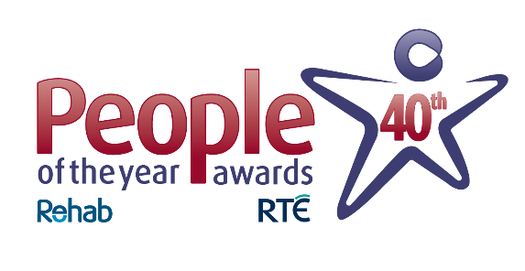
Nominations are now open for the 2014 People of the Year Awards, organised by Rehab.
2014 marks the 40th anniversary of the Awards, which first be gan in 1975 and celebrate the outstanding contributions made by individuals and organisations to Irish life. The Awards ceremony will be broadcast live on RTÉ One on Saturday, 6th December 2014.
All winners are proposed by the Irish public and then finalised by a panel of adjudicators. Nominations can be submitted for a number of specific categories, including International Person of the Year, Young Person of Year, Sports Person of the Year and Community Group of the Year.
Nominees can also be put forward for general People of the Year awards for those who do not necessarily fit into the categories listed above.
If you know someone who has done something extraordinary, who has made a real difference or who has inspired those around them, then please consider nominating them now at www.peopleoftheyear.com. The closing date for nominations falls on Friday, 5th September 2014.
For more information, please email Siobhan O’Reilly at siobhan.reilly@peopleoftheyear.com or call 01 205 7397.

Open Training College Launches New Website for Training in Disability Sector
The Open Training College recently launched its new website promoting educational training options for people working or seeking work in the disability and non-profit sector.
The site contains an extensive range of training courses that offer something to people who are keen to upskill and move ahead with their careers, while also providing introductory courses to those starting out in the disability and wider non-profit sectors. The College offers students the flexibility of studying short courses, such as Person-Centred Planning, as well as certificate and degree awards in Social Care and Management.
Courses are delivered through the award-winning Supported Open Learning model, a type of distance learning approach that allows students to continue working in human services, whilst studying practical accredited courses which embody best practice. The site also highlights the valuable consultancy service that the College offers to organisations working in the community and voluntary sector.
“I think I would award an A1 grade to the Open Training College because it has enabled me to make an impact on the ground within my disability service. The application of learning is key to allowing change to take place on the ground”, confirmed Don Campbell, a regional service manager with the Irish Wheelchair Association and graduate of the Social Care degree with the Open Training College.
To access the new website, please visit www.opentrainingcollege.com

New Regulations May Ease “Crisis Point” in Wheelchair Taxi Numbers
In April 2014, new regulations on the taxi industry were introduced by the National Transport Authority, many of which relate to wheelchair-accessible taxis. Stephen Cluskey, founder of Wheelchairtaxi.ie, was involved in the committee process which decided on these measures. Here, he highlights some of the changes and gives his opinion on them.

In terms of accessibility, the new taxi regulations are not perfect, but they are the most significant changes we have seen in a very long time, aiming to help wheelchair taxi drivers and their passengers.
Image by fotographic1980, courtesy of freedigitalphotos.net

Let’s start with one that seemed to get some media attention: the lowering of standards for a wheelchair-accessible taxi. Previous regulation stated that a wheelchair-accessible taxi must be able to take “a wheelchair user plus three passengers”, but this has been changed to “a wheelchair user plus one passenger”. This opens up the Irish market to more affordable vehicles, such as the Peugeot Premier, which cost in the region of €27,500, including Value Added Tax (VAT) and Vehicle Registration Tax (VRT); previously, the cheapest new wheelchair-accessible taxi a driver could purchase was upwards of €40,000. These operate great as a regular taxi and feel far more comfortable for a wheelchair user in comparison to many of the seven-seaters currently out there. They provide taxi drivers who want to do wheelchair work with a good alternative option to what is currently out there, at a far more reasonable price.
There is no maximum age limit for current operating wheelchair-accessible taxis, and this will not be changed. The reason behind this is because there has been such depletion in numbers (more than 40% in the last two years alone) that, if these vehicles were taken off the road, they would not be readily replaced. Some of these vehicles are not fully suitable (although many are), but I think it is better to have something rather than nothing at all. I know from experience it is not pleasant being stranded with no way home as there is no wheelchair-accessible taxi, and taking these vehicles off the road overnight would only make the situation for wheelchair users much worse.
Old Wheelchair Accessible Taxi Regulations
• No maximum age limit for current vehicles
• New or replacement vehicles to be under 10 years
• Large wheelchair accessible vehicles only allowed (wheelchair user plus three passengers)
• No ‘licence swap’ allowed from standard taxi

New Wheelchair Accessible Taxi Regulations
• No maximum age limit for existing wheelchair accessible vehicles
• New or replacement vehicles to be under six years
• New or replacement vehicles age limit of 15 years
• Large and medium wheelchair accessible vehicles allowed (wheelchair user plus one passenger)
• Allow ‘licence swap’ from standard taxi to wheelchair accessible taxi plus return
• Vehicle age for ‘licence swaps’ of less than six years

New and replacement wheelchair-accessible taxis will, however, be subject to a 14 year age limit rule, in comparison to ten years for a saloon taxi. New wheelchair tax is will also now need to be less than six years old, in comparison to three years for a saloon taxi. This six-year rule was introduced to try to bridge the price difference between saloon and wheelchair taxis, making the latter more affordable for drivers, with a longer lifespan of 14 years.
Under the new regulations, drivers will now be able to swap their existing licence from a standard taxi to a wheelchair accessible taxi, which they previously could not do. They can also change back to their saloon licence if they wish; this gives the driver some flexibility should they wish to pursue either route. Personally, I would prefer a driver not to be able to change back, as I feel we should be moving towards a taxi industry which is inclusive to everyone in society, but can understand the thinking behind this as many drivers invested significantly in their saloon licences. The six-year rule also applies to the wheelchair-accessible vehicle age for a licence swap.
These new regulations are not perfect, but I believe they will go a long way to encouraging more drivers to opt for a wheelchair-accessible taxi over a saloon in a time where, for example, there are only two wheelchair-accessible taxis throughout the whole of Tipperary. I recently got an e-mail from someone in Donegal who couldn’t get a wheelchair-accessible taxi to take their mother to the funeral of her own husband. These sorts of stories are rarely heard about, but happen everyday and they are not acceptable in Ireland 2014. Taxis are the only real door to door public transport service for many people, and should not exclude members of our society. We are at crisis point with wheelchair taxi numbers, even though the taxi industry as a whole is a saturated market, but I see these new regulations as a good first step to going some way to addressing this issue.
To read more about the new regulations, go to http://www.wheelchairtaxi.ie/wheelchair-taxi-regulations-2014#sthash.l9cg9ftj.dpuf. To find out more about Wheelchairtaxi.ie, visit http://www.wheelchairtaxi.ie/

Currently, there are only two wheelchair-accessible taxis in the whole of County Tipperary. Stephen hopes these new regulations will begin to change similiar shortages across the country.

DFI MEMBER ORGANISATIONS | NEWSLETTER DIRECTORY
For information, please contact the member organisations directly.
Irish Kidney Association Visit http://www.ika.ie/services/support-magazine-archive
Irish Motor Neuron Disease Association Subscribe to newsletter at www.imnda.ie
Irish Wheelchair Association Visit www.iwa.ie/information/publications/spokeout-magazine
Livability Subscribe to e-mail updates at http://www.livability.org.uk/
Migraine Association of Ireland Subscribe to monthly e-zine at http://www.migraine.ie
Move 4 Parkinsons Visit http://www.move4parkinsons.com/join-move4parkinsons/
Multiple Sclerosis Society of Ireland Subscribe to e-newsletters at www.ms-society.ie
Muscular Dystrophy Ireland Subscribe at http://www.mdi.ie/newsletter-by-email.html
National Council for the Blind of Ireland Magazine at http://www.ncbi.ie/news/ncbi-news-magazine
Neurofibromatosis Association of Ireland Subscribe to newsletter at www.nfaireland.ie
Offaly Centre for Independent Living Email sarah@ocil.ie to subscribe to monthly newsletter
Neurological Alliance of Ireland Sign up to newsletter at http://www.nai.ie/
Parkinsons Association of Ireland Visit http://www.parkinsons.ie/mediacentre_publications
Post Polio Support Group Newsletters at http://www.ppsg.ie/publications_survivor.html
Rehab Group Visit http://www.rehab.ie/about/rehabnews.aspx
Roscommon Disability Support Group Email mganly@rosdisabilities.ie to request copies of newsletters
Spina Bifida Hydrocephalus Ireland ‘Ability’ magazine at http://www.sbhi.ie/ability-magazine.html
Special Olympics Ireland Subscribe at http://www.specialolympics.ie/home.aspx
Spinal Injuries Ireland ‘Spinal News’ at http://www.spinalinjuries.ie/?page_id=164
Walkinstown Association Visit http://www.walk.ie/info_newsletter
Yoobyoo (formerly Children In Hospital Ireland) Subscribe to newsletter at http://yoobyoo.ie/

ACTS (Accessible Community Transport Southside) Newsletter available at www.actsltd.ie
Acquired Brain Injury Ireland Newsletter available at www.abiireland.ie/publications.html
Arthritis Ireland Subscribe to e-zine at www.arthritisireland.ie
Aware Subscribe to e-newsletter at www.aware.ie
Bodywhys Subscribe to newsletter at www.bodywhys.ie,
Bray Lakers Visit www.braylakers.ie/Newsletter/190 for newsletters
Care Alliance Ireland Visit http://www.carealliance.ie/publications_newsletters
Carers Association Subscribe at hwww.carersireland.com/newsletters.php,
Carmichael Centre Sign up for news at http://www.carmichaelcentre.ie/news
Disabled Drivers Association Subscribe to newsletter at http://www.ddai.ie
Down Syndrome Ireland Twice-yearly magazine available to members of the organisation
Dyslexia Association of Ireland Visit http://www.dyslexia.ie/about/download-section/
Enable Ireland E-newsletter at http://www.enableireland.ie/newsletter
Epilepsy Ireland Visit http://www.epilepsy.ie/index.cfm/spKey/news.html
Féach Subscribe to newsletter at http://feach.ie/index.php/newsletter
Fighting Blindness Visit http://www.fightingblindness.ie/news/email-newsletter/
GROW Subscribe at http://grow.ie/blog/publication_titles/newsletters/
Irish Guide Dogs Association Visit http://www.guidedogs.ie/iopen24/newsletters.php
HAIL (Housing Association for Integrated Living) Download newsletters at http://www.hail.ie/publications.htm
Headway Monthly e-newsletter at http://www.headway.ie/stayintouch
Heart Children Ireland Subscribe at http://www.heartchildren.ie/sign-our-newsletter
Huntington’s Disease Association of Ireland Visit http://www.huntingtons.ie/content/hope-newsletter-0
Irish Haemophilia Society Subscribe at http://www.haemophilia.ie/newsletter.php

DFI SUPPORT OFFICERS | CONTACT DETAILS

National Office
Fumbally Court Fumbally Lane, Dublin 8
Tel: 01 454 7978 Fax: 01 494 7981
E: info@disability-federation.ie

Dublin Mid-Leinster
Anthony Carrick (Dublin Office)
Dun Laoghaire, Dublin South East, Wicklow Mobile: 086 820 6736
E: anthonycarrick@disability-federation.ie

Louise McCann (Dublin Office)
Dublin South City, Dublin South West, Dublin West, Kildare, West Wicklow (Dublin Office)
Mobile: 086 918 9750
E: louisemccann@disability-federation.ie
Jacqueline Grogan (Dublin Office)
Laois, Offaly, Longford, Westmeath
Tel: 01 708 0108
Mobile: 086 388 2600
E: jacquelinegrogan@disability-federation.ie

Joan O’Connor (currently on leave)
Support Officer: Policy and Research
Tel: 01 425 0121
E: joanoconnor@disability-federation.ie

Dermot O’Donnell (Dublin Office)
Support Officer: Support for Organisations
Tel: 01 425 0125
E: dermotodonnell@disability-federation.ie

Dublin North-East
Joan O’Donnell (Dublin Office)
Meath, Louth, Cavan, Monaghan
Mobile: 086 383 4587
E: joanodonnell@disability-federation.ie

Martin Naughton
Dublin North Central, Dublin North, Dublin West
Mobile: 086 820 7196
E: martinnaughton@disability-federation.ie

West
Michael Corbett
Galway, Mayo, Roscommon
C/O DFI, 8 Acres Grove, Newport, Co. Mayo,
Tel: 098 41919
Mobile: 086 380 4750
E: michaelcorbett@disability-federation.ie
North-West
Jennifer Van Aswegen
Sligo, Leitrim, Donegal
Disability Federation of Ireland
Unit 2C, Castle House, Castle Street, Sligo.
Mobile: 086 381 1261
E: jennifervanaswegen@disability-federation.ie
Toni Gleeson
Limerick, North Tipperary, East Limerick, Clare
DFI, The Forge, Croke Street, Thurles, Co Tipperary
Mobile: 086 600 4526
E: tonigleeson@disability-federation.ie

South
P.J. Cleere
Carlow, Kilkenny, South Tipperary, Waterford, Wexford
DFI, Tinryland, Carlow
Tel: 059 917 9431
Mobile: 086 381 1064
E: pjcleere@disability-federation.ie

Alison Ryan
Cork, Kerry
101 North Main Street, Cork.
Tel: 021 427 1752
Mobile: 086 381 6323
E: a.ryan@disability-federation.ie

Representing the interests and expectations of people with disabilities to be fully included.
Comprising organisations that represent and support people with disabilities.

The Disability Federation of Ireland (DFI) represents the interests and the expectations of people with disabilities to be fully included in Irish society. It comprises organisations that represent and support people with disabilities and disabling conditions.
The vision of DFI is that Irish society is fully inclusive of people with disabilities and disabling conditions so that they can exercise their full civil, economic, social and human rights and that they are enabled to reach their full potential in life. DFI’s mission is to act as an advocate for the full and equal inclusion of people with disabilities and disabling conditions in all aspects of their lives.
There are over 130 organisations within membership or as associates of DFI. DFI also works with a growing number of organisations and groups around the country that have a significant disability interest, mainly from the statutory and voluntary sectors. DFI provides:
- Information
- Training and Support
- Networking
- Advocacy and Representation
- Research and Policy Development / Implementation
- Organisation and Management Development
DFI works on the basis that disability is a societal issue, and so works with Government and across the social and economic strands and interests of society.
Disability Federation of Ireland, Fumbally Court, Fumbally Lane, Dublin 8
Tel: 01 454 7978 Fax: 01 454 7981
Email: info@disability-federation.ie Web: www.disability-federation.ie

Disability Federation of Ireland is a company limited by guarantee not having share capital, registered in Dublin. Registered No. 140948, CHY No 6177

